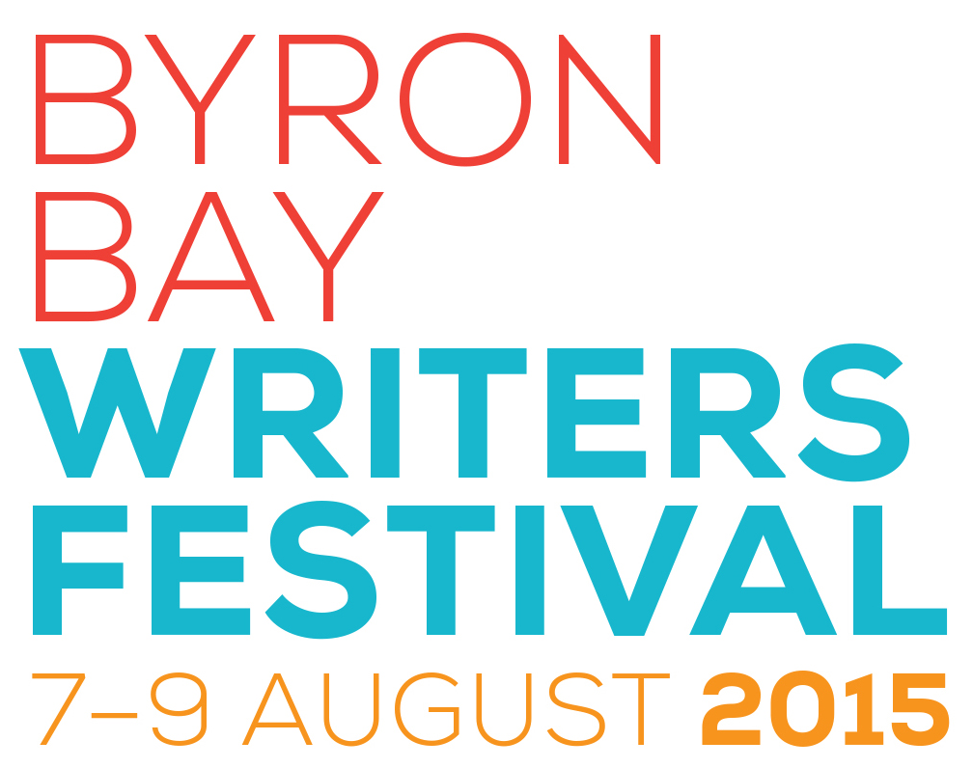



**Calling All Poets !**

**2015 Dangerously Poetic Byron Bay Writers Festival**

**Poetry Prize**

Dangerously Poetic and the Byron Bay Writers Festival are sponsoring a national poetry prize to be awarded at the Byron Bay Writers Festival on Saturday, 8 August at an off-site venue, *The Lone Goat Gallery*, Byron Bay.

Poets are invited to write up to **40** lines on the theme- *Change.*

Judge: Krissy Kneen

First Prize : $500, a 3 day pass to the Byron Bay Writers Festival 2015, publication in Dangerously Poetic's upcoming anthology (projected launch date 4/2016), a free copy of the anthology and an opportunity to read the poem at an offsite Festival event.

Second Prize : $100, 1 day pass (Sunday) to Byron Bay Writers Festival 2015, publication in Dangerously Poetic's upcoming anthology and an opportunity to read poem at an offsite Festival event.

For entry forms, download on [www.dangerouslypoetic.com](http://www.dangerouslypoetic.com/)